**Unearthing the Environmental Impact of Human Activity: A Global CO2 Emission Analysis**

**Introduction:**

**Overview:**

Carbon dioxide (CO2) is a gas that is naturally present in our atmosphere. However, excessive CO2 emissions are considered one of the most significant contributors to climate change. Over the past few decades, human activities such as burning fossil fuels for energy, transportation, and industrial processes have led to a significant increase in CO2 emissions.

**Purpose:**

The purpose of CO2 emission analysis is to evaluate the amount of CO2 that is being released into the atmosphere due to the human activities. This type of analysis is often conducted by governments, environmental agencies, and private organizations to determine the impact of human activities on the environment and identify potential solutions to reduce emissions.

**Problem Definition and Design Thinking:**

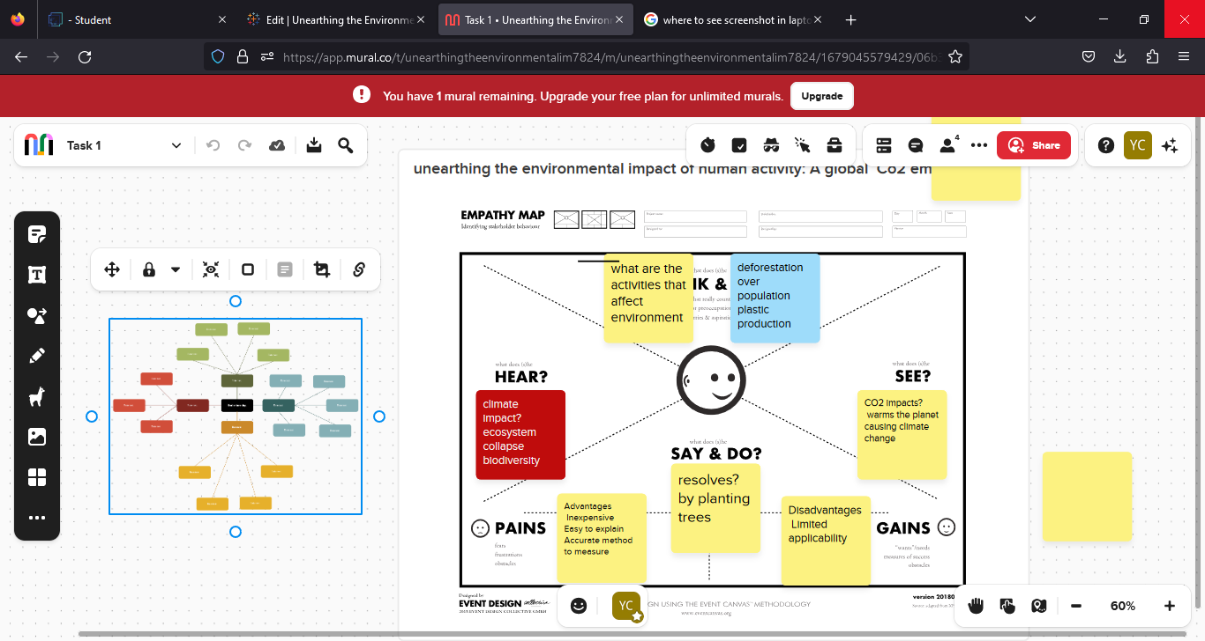

**Results:**

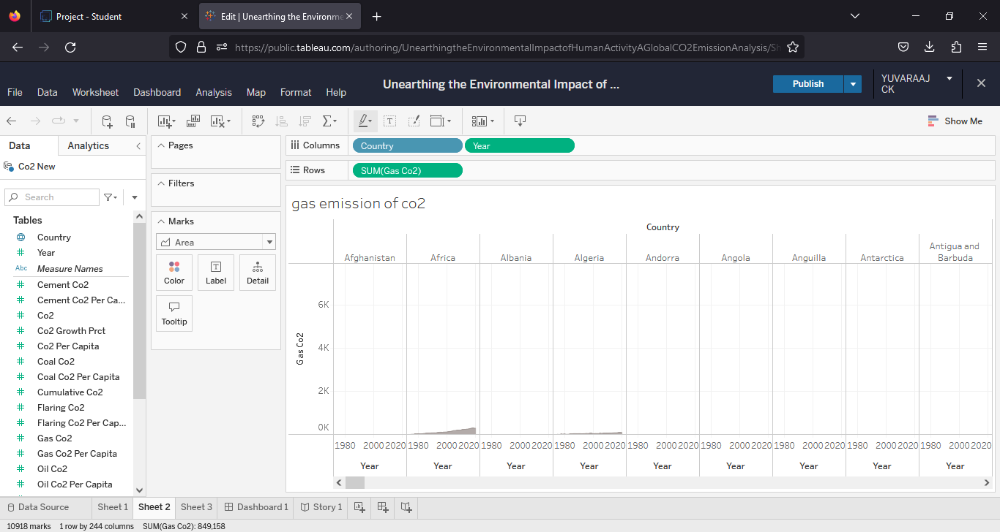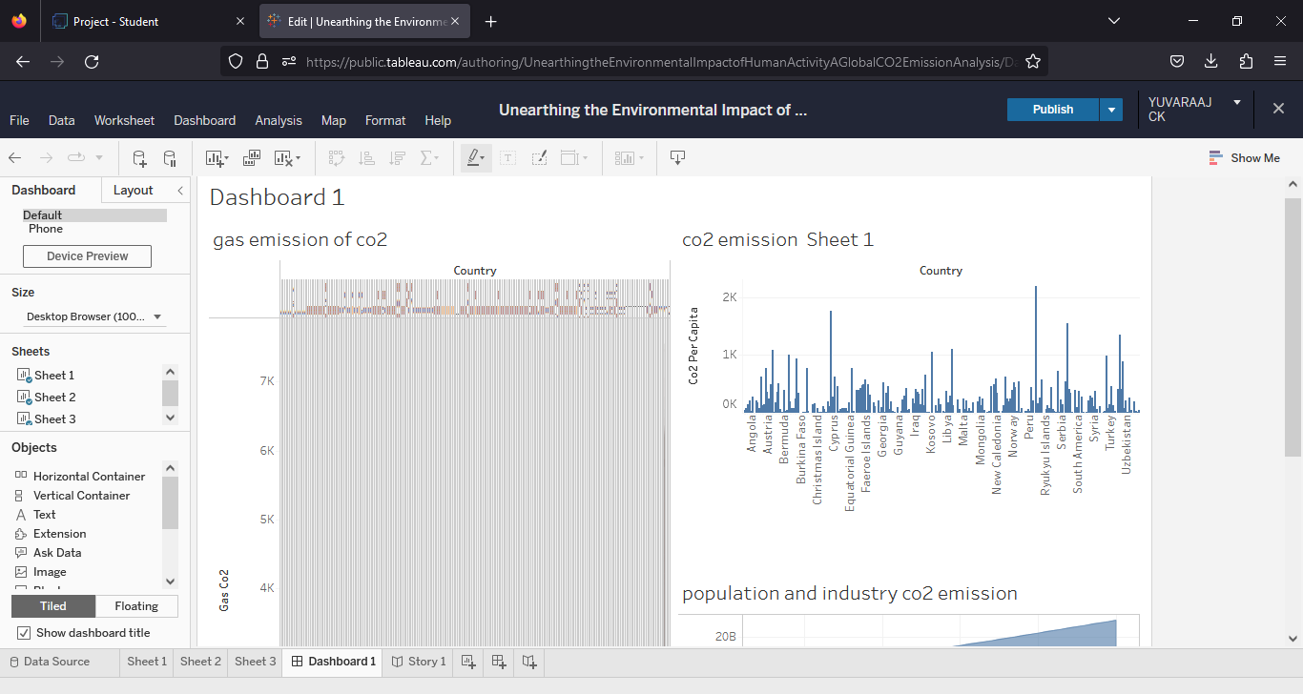

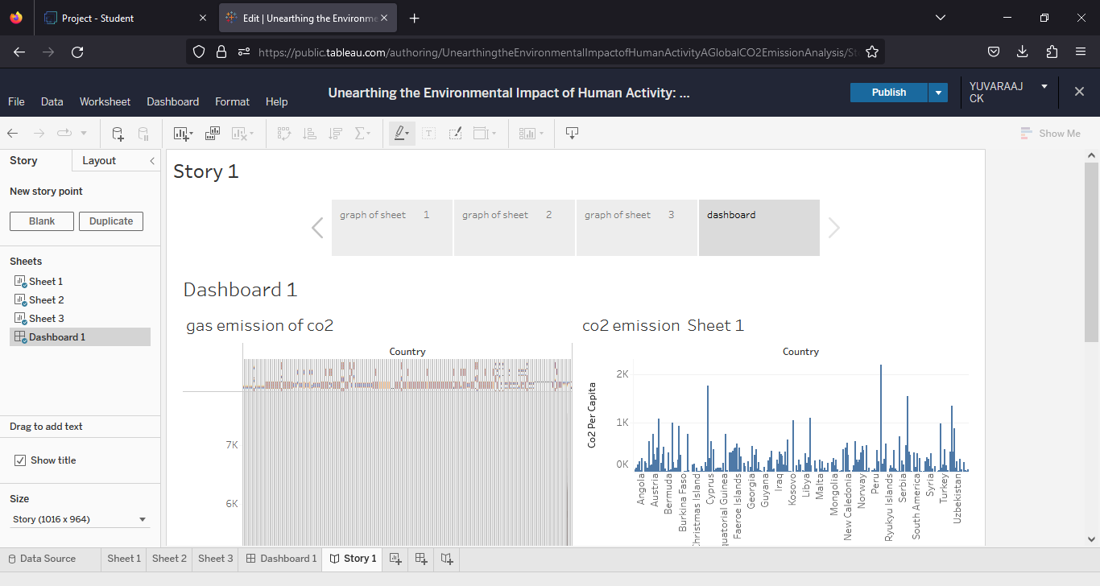

**Advantages:**

* Identification of sources
* Setting targets
* Improving efficiency
* Creating employment
* Technological advancement

**Disadvantages:**

* Costs
* Uncertainty
* Lack Of Uniformity
* Difficuly in implementation
* Economic impact

**Applications:**

* Monitoring emission
* Supporting policy decisions
* Assessing environmental impact
* Enabling carbon credit trading
* Supporting corporate sustainability reporting

**Conclusion:**

CO2 emission analysis has various advantages disadvantages and applications and it has worldwide effort. It has technological innovations

**Future scope:**

* Improved technological solutions
* Integration of AI and Big data
* Shift Towards electric vehicles
* Development of carbon capture